Jack Berthiaume
12/18/2020
Final Draft Social Media Copy
Professional Short Form Writing

Beer, Vinyl, Coffee Social Media Copy

Platforms: Facebook and Instagram

Editor’s Note: Due to the fictional nature of BVC universe, many of the links and organization websites mentioned do not exist. The underline feature and color blue have been added for visualization purposes and are not intended to lead to an actual website. Alt text would be added to any published post. Additionally, COVID-19 does not exist in the happy world of the BVC alternate universe.

- (Facebook & Instagram) Beer, Vinyl, Coffee. We bring people together. #bvc

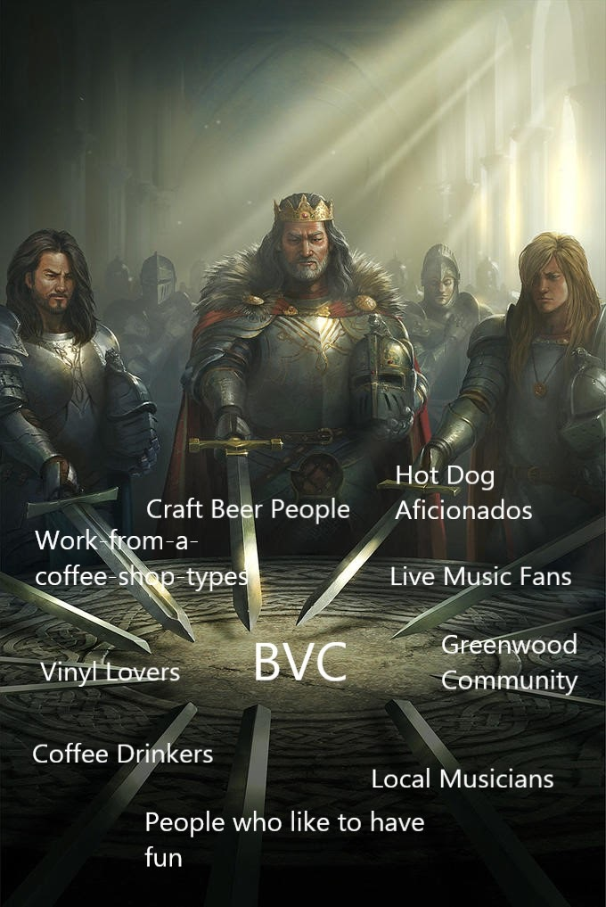

- (Facebook & Instagram) We don’t stop at Beer. Or Vinyl. Or Coffee. At BVC, we believe there should be something for everybody. Subscribe to our newsletter for the deals only regulars know about, like this weekend’s deal with @MacaronsbyMarcus. #macarons #pnw #beer #vinyl #coffee #BVC
Link to Newsletter

- (Facebook & Instagram) We partnered with @PineTreeRoasters for two reasons: They’re the best at what they do, and they treat people right while doing it. Pine Tree Roasters coffee is certified fair trade, organic, and sustainably sourced. Put the #good in a #good cup of joe and get your cup of warm, ethical, liquid deliciousness at BVC today.

- (Facebook & Instagram) Heavy Horses Brown Ale is back on tap tonight at BVC. Whether your tool of choice is a tractor or trackpad, work horses everywhere can rejoice with our balanced Brown Ale. If we were to toot our own horns, we’d say this beautiful amber brew is malty perfection for the post-commute pour. #beer #vinyl #coffee #brownale #BVC #greenwood

- (Facebook) Have you ever had a hot dog with every permutation of: Ketchup, Mayonnaise, Sriracha mayonnaise, dill pickle spears, chopped onions, kimchi, sauteed chopped onions, sauerkraut, fried onion, pickled jalapenos, Dijon mustard, hot peppers, giardiniera, honey mustard, rice, pickle relish, tomatoes, fried egg, lettuce, avocado, nori, garlic onion jam, vegemite, and BBQ sauce?

No? Then I guess we’ll see you tonight for our hot dog special. Get TWO quality dogs for $8 this weekend ONLY at BVC. #noleashneeded #bestinshow #gourmetdogs #hotdiggitydog #seattle #beer #vinyl #coffee #BVC

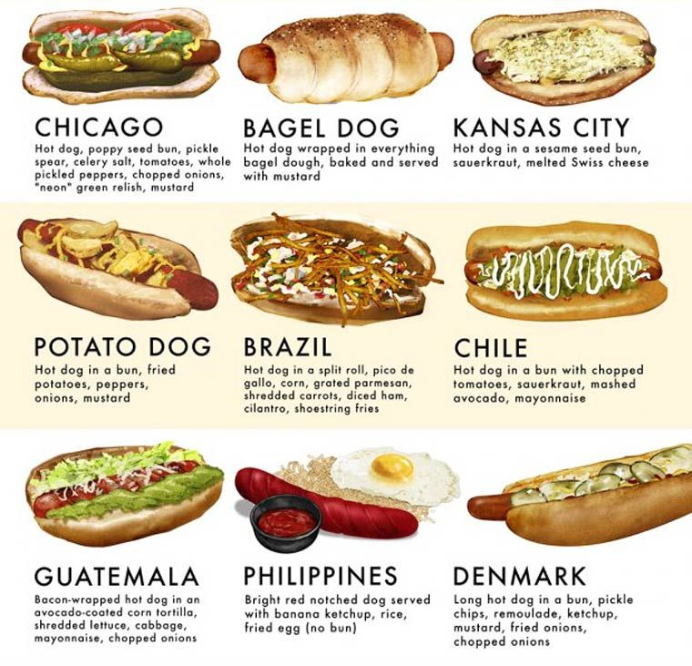

- (Facebook) Multiple Choice Pop Quiz. Please choose only one.
A French press is:
a.) The technique known among Parisienne pastry chefs to get baguettes to be just the right shape
b.) A special grinder used to push potatoes into the delightful French fry shape we all know and love
c.) A nickname for ice-hockey great Mario Lemieux’s aggressive play on offense
d.) The device pictured below:

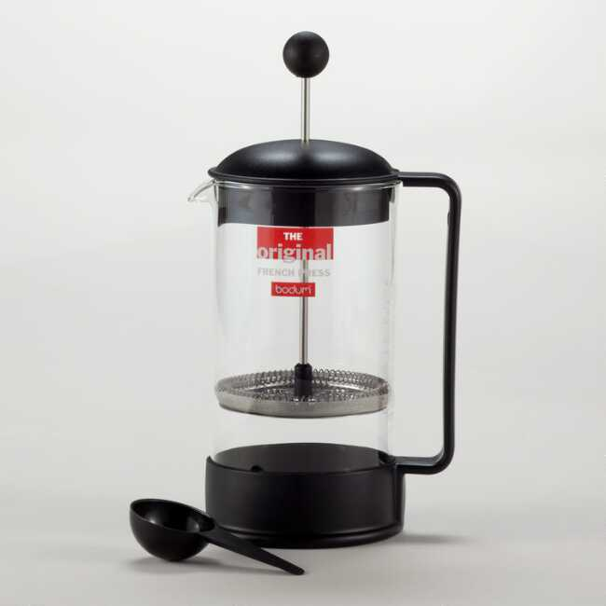

If you guessed “a,” “b,” “c,” or “d,” then you know enough about coffee to taste the difference in a BVC cup. Stop by today! #frenchpress #seattlecoffee #oohlala #beer #vinyl #coffee #BVC #paris2greenwood

- (Facebook) If you can read this, you’re who we’re looking for!

We’re going to come clean. We made a Facebook ad to target people who like beer, vinyl, and coffee. We hope that’s you! If so, you’re exactly the kind of person who we think would like to stop by BVC. We are Seattle’s number one stop for a cup of joe, vinyl records, a pint to end the workday, and so much more! #beer #vinyl #coffee #BVC #seattle #emeraldcitygems

- (Facebook) Conservation Washington is a conservation group dedicated to protecting Washington’s natural spaces based right here in Greenwood. Last weekend we had an amazing time hosting @ConservationWashington for their annual volunteer appreciation party! One of the best parts of running BVC is hosting nonprofit groups at a reduced rate. Do you work or volunteer at a local nonprofit or mission-driven organization? Visit the page below to learn more! #keepwashingtonwild #greenwoodlove #givingtuesday

Link to Conservation Washington Home Page

- ***GIVEAWAY***
Support local music and look good doing it by participating in our giveaway! Win $50 worth of merch and music from Seattle musicians featured at BVC this week. Entering is as simple as − wait for it − 1, 2, 3:
1. Like us on Facebook
2. Share this post
3. Live close enough to BVC to claim your prize should you win!
Four lucky fans will be randomly selected among users who follow this page and share this link on January 7, 2021. Each will receive a gift card worth $50 towards any of our Seattle artists’ merch and music in-store. Now get sharin’ and win some free stuff!!

- You can only keep 10 of the 12 beer types pictured below. Which two are you getting rid of??? #nothankyou #thehorror
